***Section* 3.2 – Infinite Series**

An ***infinite series*** is the sum of an infinite sequence of numbers



The sum of the first *n*th terms 

|  |  |  |  |
| --- | --- | --- | --- |
| ***Partial Sum*** |  | ***Value*** | ***Suggestive Expression***  ***For Partial Sum*** |
| *First* |  | 1 | 2 − 1 |
| *Second* |  |  |  |
| *Third* |  |  |  |
|  |  |  |  |
|  |  |  |  |

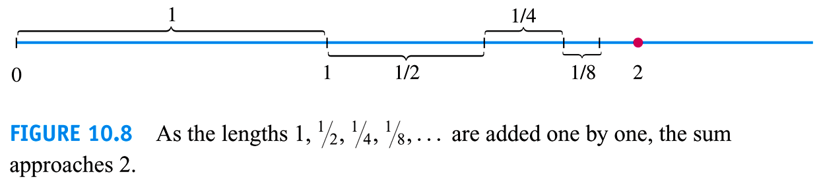

***Definition***

Given a sequence of numbers , an expression of the form  is an ***infinite series***. The number  is the ***n*th term** of the series. The sequence  is defined by











Is the ***sequence of partial sums*** of the series, the number  being the ***n*th partial sum**. If the sequence of partial sums converges to a limit *L*, we say that the series **converges** and that its **sum** is *L*.

In this case, we also write



If the sequence of partial sums of the series does not converge, we say that the series diverges.

***Geometric* Series**

Geometric series are series of the form



In which *a* and *r* are fixed real numbers, and .

The series can also be written as 

**Definition of *Geometric* Sequence**

A sequence  is a geometric sequence if  and if there is a real number  such that for every positive integer *k*.



The number  is called the ***common ratio*** of the sequence.

***The formula for the nth Term of a Geometric Sequence***:



***Theorem*: Formula for **

The *n*th partial sum  of a geometric sequence with first term  and common ratio  is



***Proof***

By definition, the *nth* partial sum  of a geometric sequence is:







***Definition***

If , the geometric series converges to 



If , the series diverges.



* The sequence may converge to a single value, which is the limit of the sequence.
* The sequence terms may increase in magnitude without bound (either with one sign or with mixed signs), in which case the sequence diverges.
* The sequence terms may remain bounded but settle into an oscillating pattern in which the terms approach two or more values, then the sequence diverges.
* The terms of a sequence may remain bounded, but wander chaotic forever without pattern, then the sequence diverges in this case.

***Example***

Find the geometric series with 

***Solution***









***Example***

The series  is geometric series with 

***Solution***

It converges to 





***Example***

Your drop a ball from *a* meters above a flat surface. Each time the ball hits the surface after falling a distance *h*, it rebounds a distance *rh*, where *r* is positive but less than 1. Find the total distance the ball travels up and down. 

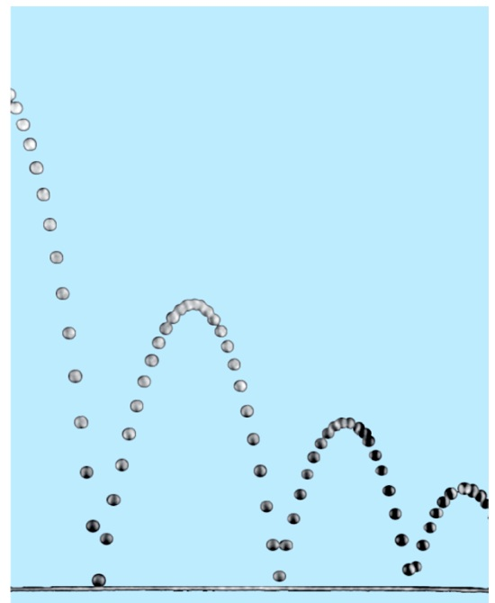 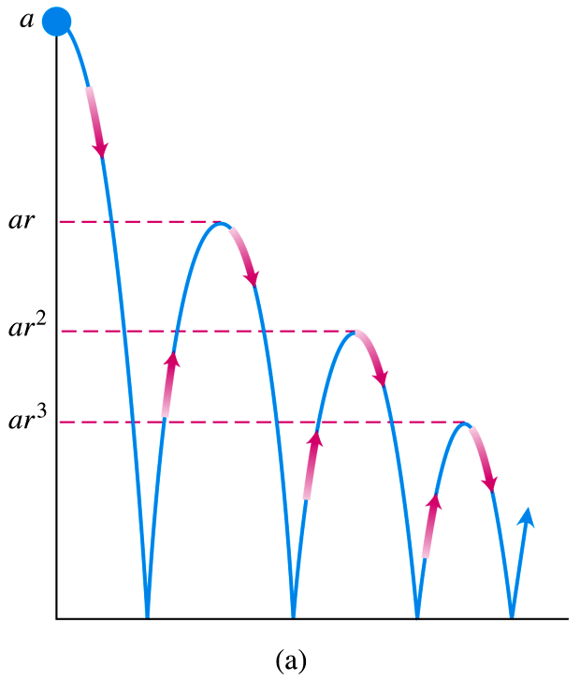

***Solution***

The total distance is









If , the distance is:





***Example***

Express repeating decimal 5.232323… as the ratio of two integers.

***Solution***













***Example***

Find the sum of the “telescoping” series .

***Solution***













**The *n*th-Term Test for a Divergent Series**

***Theorem***

If  converges, then 

***The nth-Term Test for Divergence***

diverges if  fails to exist or is different from zero.

***Example***

1. The series  diverges because each term is greater than 1, so the sum of the *n* terms is greater than *n*. 
2.  diverges because 
3.  diverges because  doesn’t exist.
4.  diverges because 

***Theorem***

If  and  are convergent series, then

***Sum Rule:*** 

***Difference Rule:*** 

***Constant Multiple Rule:*** 

* Every nonzero constant multiple of a divergent series diverges.
* If  converges and  diverges, then  and  both diverge.

***Example***

Find the sums of the series 

***Solution***













***Example***

Find the sums of the series 

***Solution***









**Adding or Deleting Terms**

We can add finite number of terms to a series or delete a finite number of terms without altering the series’ convergence or divergence.









***Exercises*** ***Section* 3.2 – Infinite Series**

(**1 − 19**) Find the limit of the following sequences or determine the limit does not exist

|  |  |  |
| --- | --- | --- |
|  |  |  |

(**20 − 24**) Find a formula for the *n*th term partial sum of the series and use it to find the series’ sum if the series converges

1. 
2. 
3. 
4. 
5. 

(**25 − 28**) Write out the first few terms of each series to show how the series starts. Then find the sum of the series

|  |  |
| --- | --- |
|  |  |

(**29 − 31**) Determine if the geometric series converges or diverges. If a series converges, find its sum

1. 
2. 
3. 

(**32 − 35**) Express each of the numbers as the ratio of two integers (fraction)

1. 
2. 
3. 
4. 

(**36 − 43**) Use Divergence to determine if the series converges or diverges.

|  |  |  |
| --- | --- | --- |
|  |  |  |

(**44 − 65**) Determine if the series converges or diverges. Give reasons for your answers. If a series converges, find its sum.

|  |  |  |
| --- | --- | --- |
|  |  |  |

|  |  |  |
| --- | --- | --- |
|  |  |  |

(**66 − 71**) Determine if the series converges or diverges and describe whether they do so monotonically or by oscillation. Give the limit when the sequence converges.

|  |  |  |
| --- | --- | --- |
|  |  |  |

(**72 − 84**) Find the limit of the following sequences or state that they diverge

|  |  |  |
| --- | --- | --- |
|  |  |  |

1. Consider the series 
2. Write the first four terms of the sequence of partial sums .
3. Write the nth term of the sequence of partial sums .
4. Find  and evaluate the series.
5. Many people take aspirin on a regular basis as a preventive measure for heart disease. Suppose a person take 80 *mg* of aspirin every 24 *hr*. Assume also that aspirin has a half-life of 24 *hrs.*; that is, every 24 *hr.* half of the drug in the blood is eliminated.
6. Find a recurrence relation for the sequence  that gives the amount of drug in the blood after the *nth* dose, where 
7. Find the limit of 
8. Suppose a tank is filled with 100 *L* of a 40% alcohol solution (by volume). You repeatedly perform the following operation: Remove 2 *L* of the solution from the tank and replace them with 2 *L* of 10% alcohol solution
9. Let  be the concentration of the solution in the tank after the nth replacement, where . Write the first five terms of the sequence 
10. After how many replacements does the alcohol concentration reach 15%?
11. Determine the limiting (steady-state) concentration of the solution that is approached after many replacements.
12. The Greeks solved several calculus problems almost 2000 *years* before the discovery of calculus. One example is Archimedes’ calculation of the area of the region *R* bounded by a segment of a parabola, which he did using the “method of exhaustion”.

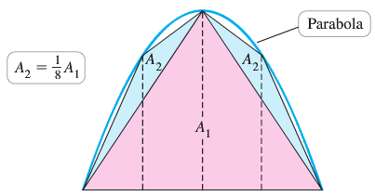

The idea was to fill *R* with an infinite sequence of triangles. Archimedes began with an isosceles triangle inscribed in the parabola, with an area , and proceeded in stages, with the number of new triangles doubling at each stage. He was able to show (the key to the solution) that at each stage, the area of a new triangle is  of the area of a triangle at the previous stage; for example, , and so forth. Show, as Archimedes did, that the area of *R* is  times the area of .

1. Evalute the series 
2. For what values of a does the the series converge, and in those cases, what is its value?



1. An insulated windows consists of two parallel panes of glass with a small spacing between them. Suppose that each pane reflects a fraction *p* of the incoming light and transmits the remaining light. Considering all reflections of light between the panes, what fraction of the incoming light is ultimately transmitted by the windows? Assume the amount of incoming light is 1.

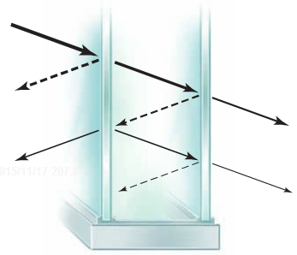

1. Suppose you borrow $20,000 for a new car at a monthly interest rate of 0.75%. If you make payments of $600/month, after how many months will the loan balance be zero? Estimate the answer by graphing the sequence of loan balances and then obtain an exact answer using infinite series.
2. Suppose a rubber ball, when dropped from a given height, returns to a fraction *p* of that height. In the absence of air resistance, a ball dropped from a height *h* requires  seconds to fall to the ground, where  is the acceleration due to gravity. The time taken to bounce up to a given to fall from that height to the ground. How long does it take a ball dropped from 10 *m* to come to rest?
3. The fractal called the snowflake island (or Koch island) is constructed as flows: Let  be an equilateral triangle with sides of length 1. The figure  is obtained by replacing the middle third of each side of  with a new outward equilateral triangle with sides of length . The process is repeated where  is obtained by replacing the middle third of each side of with a new outward equilateral triangle with sides of length of . The limiting figure as  is called the snowflake island.

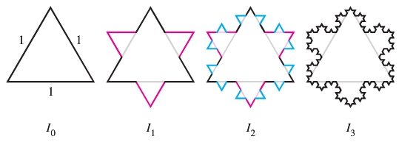

1. Let  be the perimeter of . Show that 
2. Let  be the area of . Find . It exists!
3. Imagine a stack of hemispherical soap bubbles with decreasing radii  Let  be the distance between the diameters of bubble *n* and bubble , and let  be the total height of the stack with *n* bubbles.

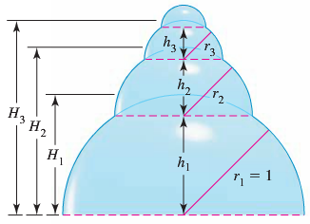

1. Use the Pythagorean theorem to show that in a stack with *n* bubbles , , and so forth. Note that for the last bubble .
2. Use part (*a*) to show that the height of a stack with *n* bubbles is



1. The height of a stack of bubbles depends on how the radii decrease. Suppose that  where  is a fixed real number. In terms of *a*, find the height  of a stack with *n* bubbles.
2. Suppose the stack in part (*c*) is extended indefinitely . In terms of *a*, how high would the stack be?
3. The fractal called the *Sierpinski* *triangle* is the limit of a sequence of figures. Starting with the equilateral triangle with sides of length 1, an inverted equilateral triangle with sides of length  is removed. Then, the three inverted equilateral triangles with sides of length  are removed from this figure.

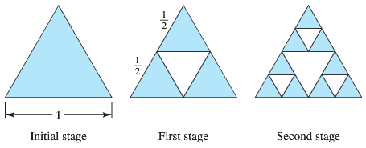

The process continues in this way. Let  be the total area of the removed triangles after stage *n* of the process. The area on equilateral triangle with side length *L* is .

1. Find  and  the total area of the removed triangles after stages 1 and 2, respectively.
2. Find  for 
3. Find 
4. What is the area of the original triangle that remains as ?
5. The sides of a ***square*** are 16 *inches* in length. A new square is formed by connecting the midpoints of the sides of the original square, and two of the triangles outside the second square are shaded.



Determine the area of the shaded regions

1. When this process is continued five more times
2. When this pattern of shading is continued infinitely.
3. A right triangle *XYZ* is shown below where  and . Line segments are continually drawn to be perpendicular to the triangle.



1. Find the total length of the perpendicular line segments  in terms of *z* and *θ*.
2. Find the total length of the perpendicular line segments when  and 
3. The sphereflake is a computer−generated fractal that was created by Eric Haines. The radius of the large sphere is 1. To the large sphere, nine spheres of radius  are attached. To each of these, nine spheres of radius  are attached. This process is continued infinitely.

Prove that the sphereflake has an infinite surface area.

